Portal Box Enclosure Guide

# Materials/Prerequisites

* At least 3400in 1.75mm diameter PLA 3D printer filament
* 3D Printer:
  + We used PrusaSlicer 2.8.0 software
  + This example was created on an Original PrusaXL printer with a 0.4mm nozzle
* Soldering iron (370º C)
* 8x 4-40 0.135in Brass Heat Set Inserts
* PrusaSlicer software, available for free [here](https://prusaslicer.net/)

# Design Options

The bottom of the box is standard for all configurations.

## [Bottom Of Enclosure:](https://drive.google.com/file/d/1V_AeusbCwUD0dHSmgCmc1y88UvvvcG6f/view?usp=drive_link)

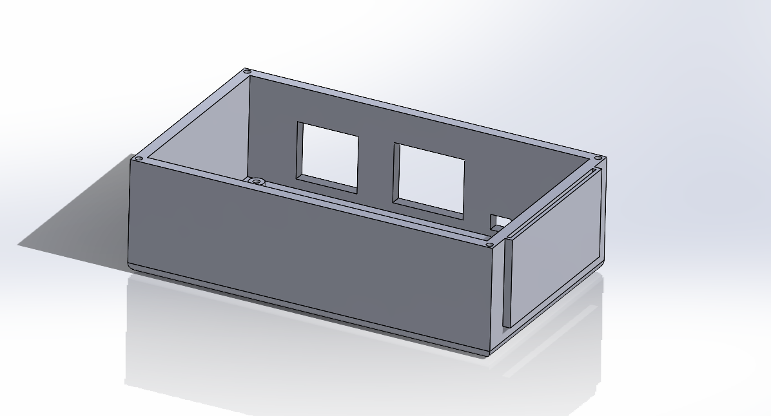

Figure 1: Enclosure

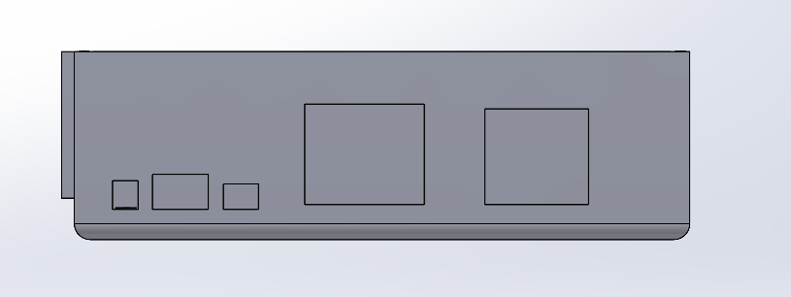

Figure 2: Enclosure rear view

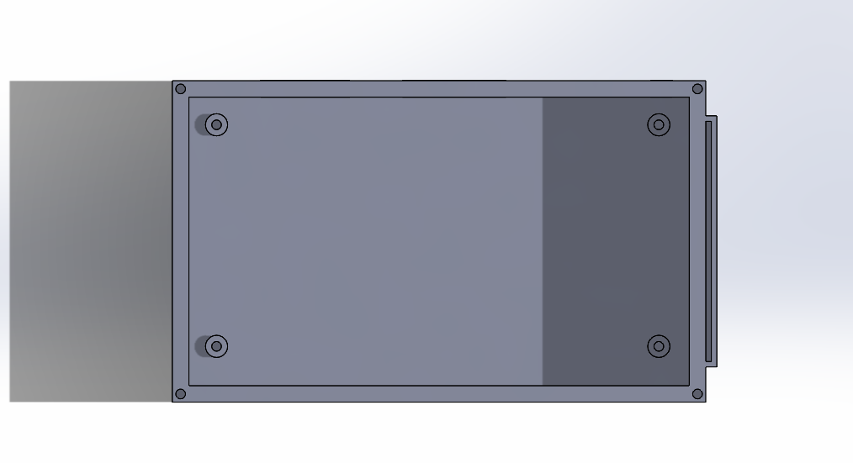

Figure 3: Enclosure top view

## [Lid Option 1: Keypad + LCD:](https://drive.google.com/file/d/1e46EqoP3oJepmiwFb82J7MjQj0g0bSy0/view?usp=drive_link)

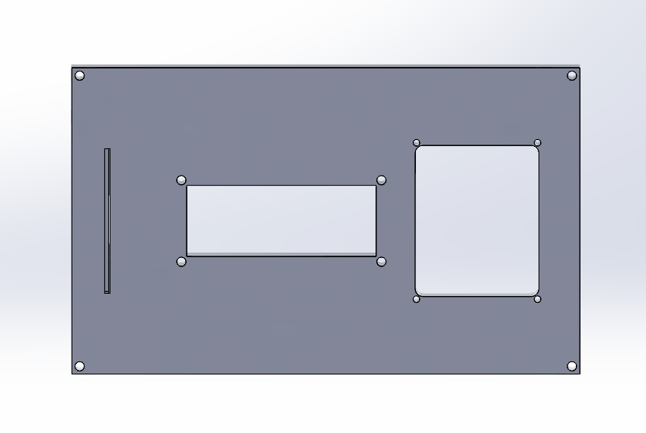

Figure 4: Lid keypad + LCD top view

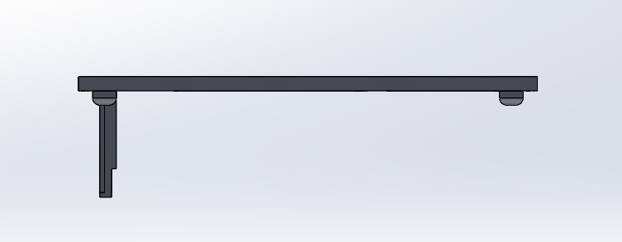

Figure 5 Lid side view

## 

## 

## 

## 

## [Lid Option 2: Button + LCD](https://drive.google.com/file/d/1RKXyrJLL7KUnwls2bY4AAVVnLYSylA5c/view?usp=drive_link)

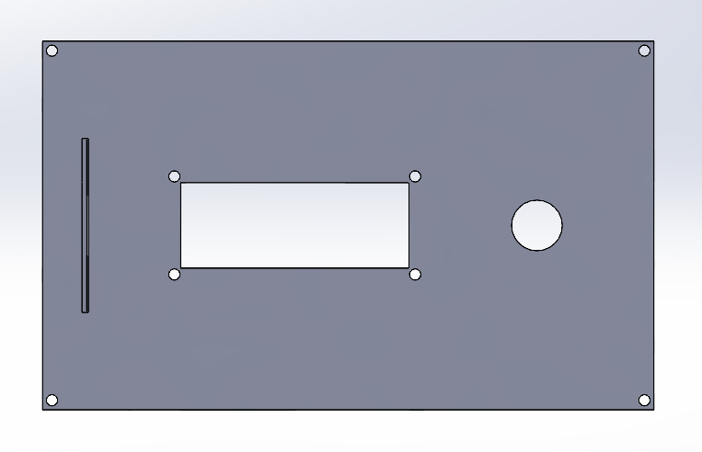

Figure 6: Lid LCD + button top view

## [Lid Option 3: Button](https://drive.google.com/file/d/1Td1Yyop_XnEjtsBR-ceI-rRVC6HV9OCx/view?usp=drive_link)

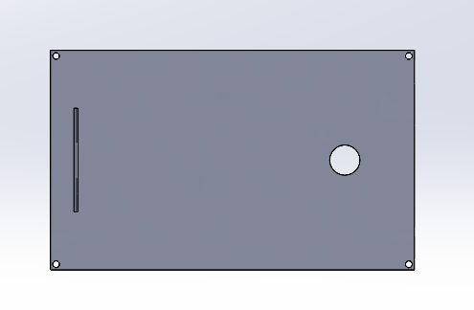

Figure 7: Lid button top view

# Printing Instructions

* Notable printer settings: this example was printed on recommended defaults set up by PrusaSlicer software for the Original PrusaXL (prints have also been accomplished with same settings on a MakerGear M2 printer, should print fine on default settings)
  + Infill: 15%
  + Supports required, recommended “Snug” supports in PrusaSlicer software
    - Overhang threshold: 65
  + Speed
    - Perimeters: 50mm/s
    - Small perimeters: 25 mm/s
    - External perimeters
  + Temperature: 290 degrees C

Enclosure Assembly

1. Remove support material from the printed enclosure. The use of a small hobby knife/tool may be required to remove the smaller supports for the rear ports as well as the supports for the card holder.
2. Place the non-threaded (circled) end of the brass inserts into the four standoff holes as well as the four holes on top of the box, as shown.

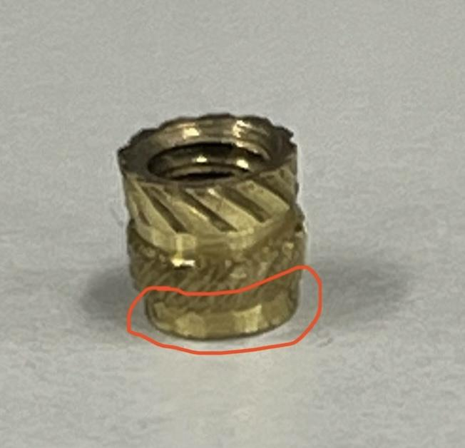

1. Place the tip of the soldering iron onto the brass insert as shown. Slowly and carefully push the insert down with the iron until it has melted into the hole. Be careful not to push too far to prevent molten plastic from getting inside the thread.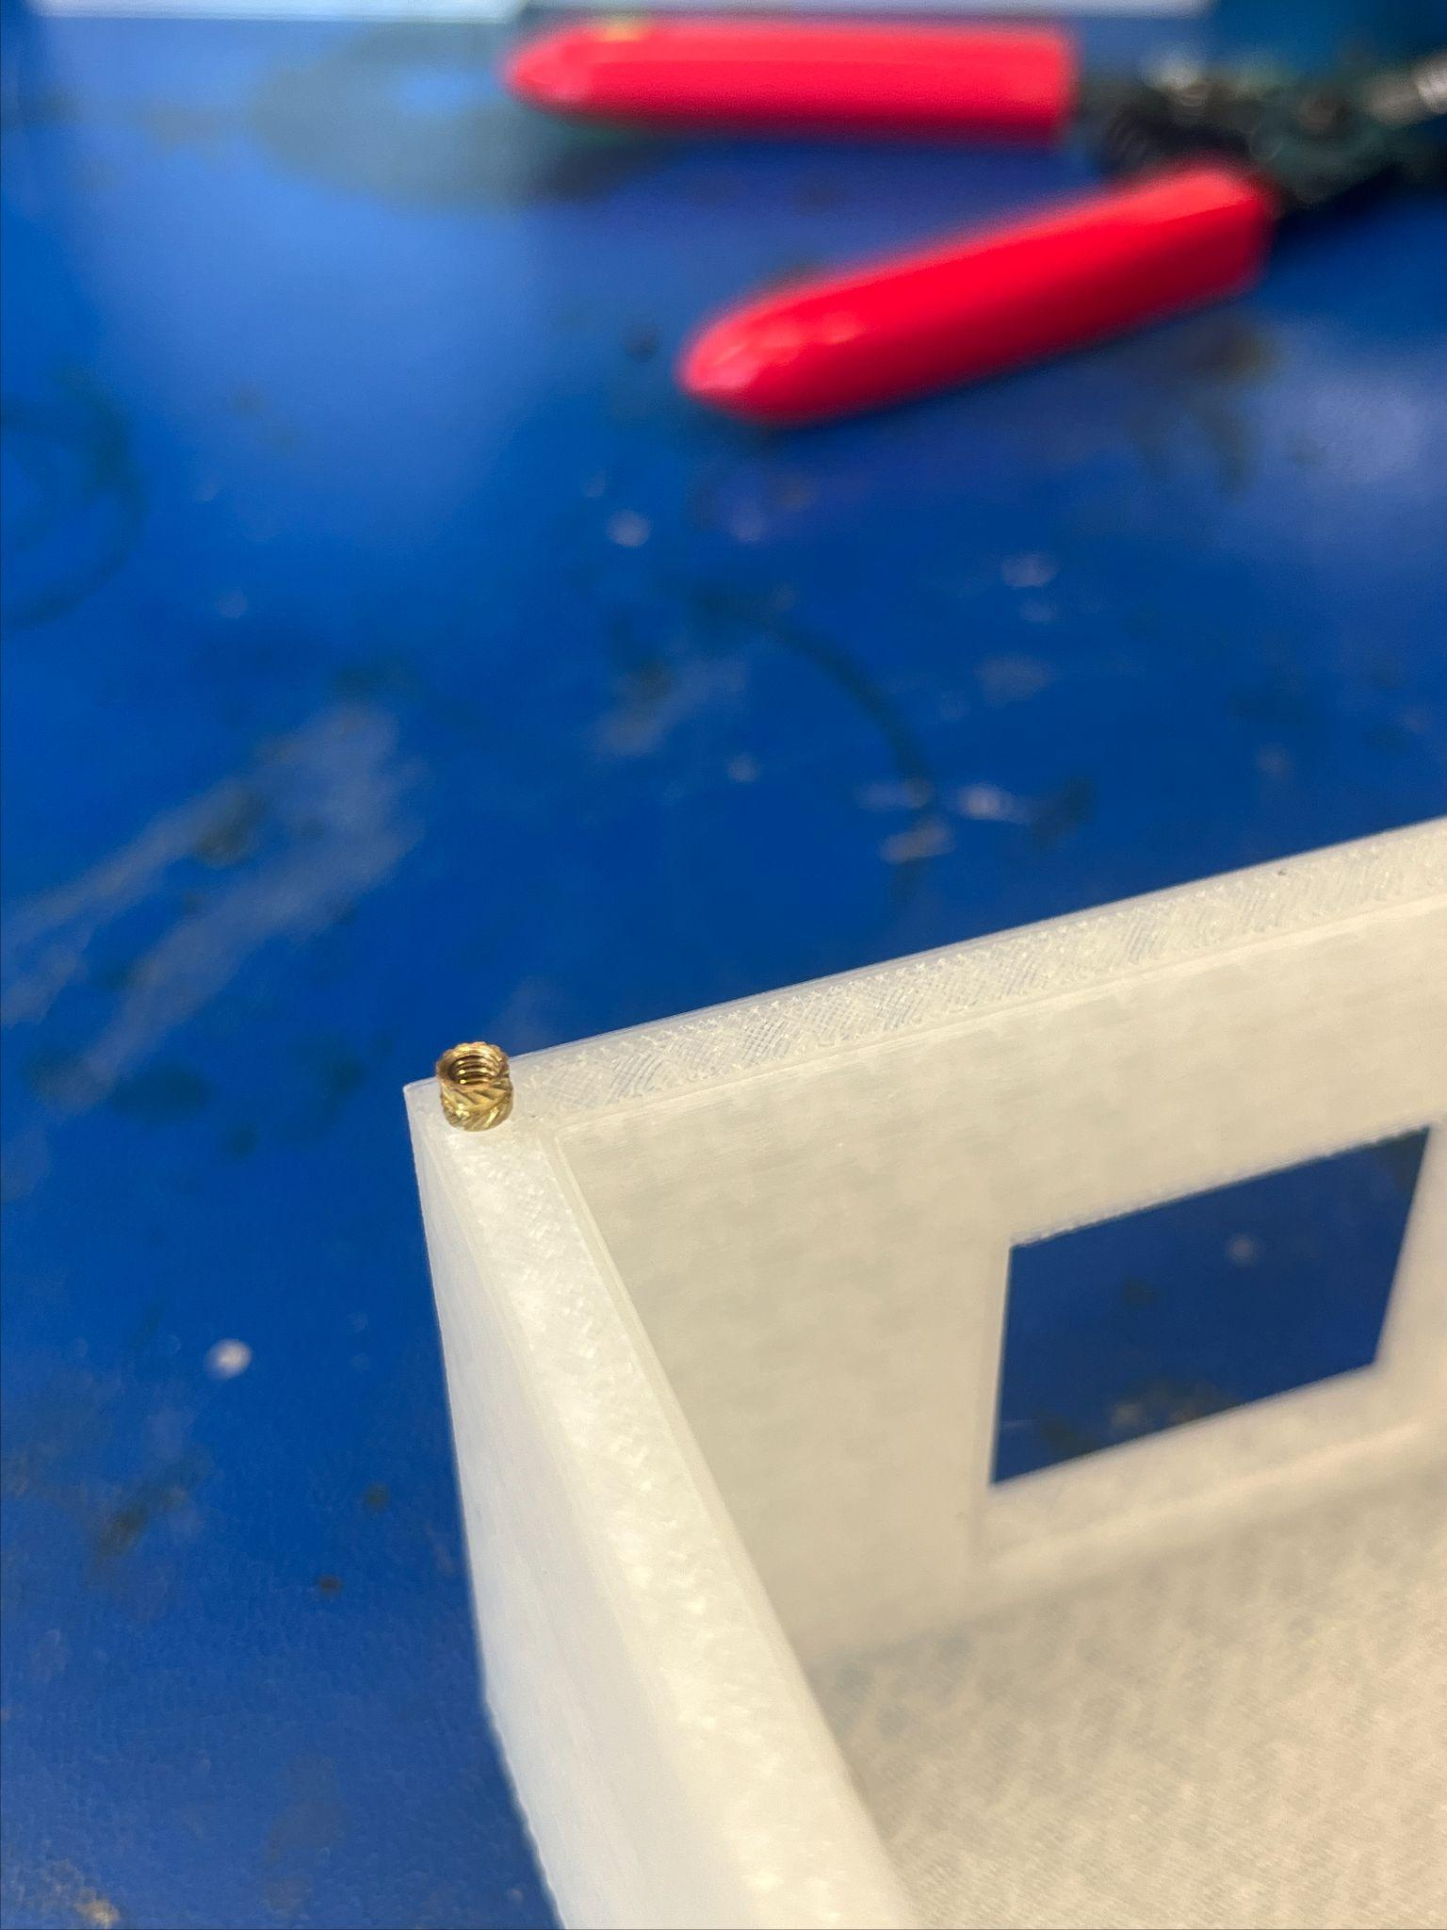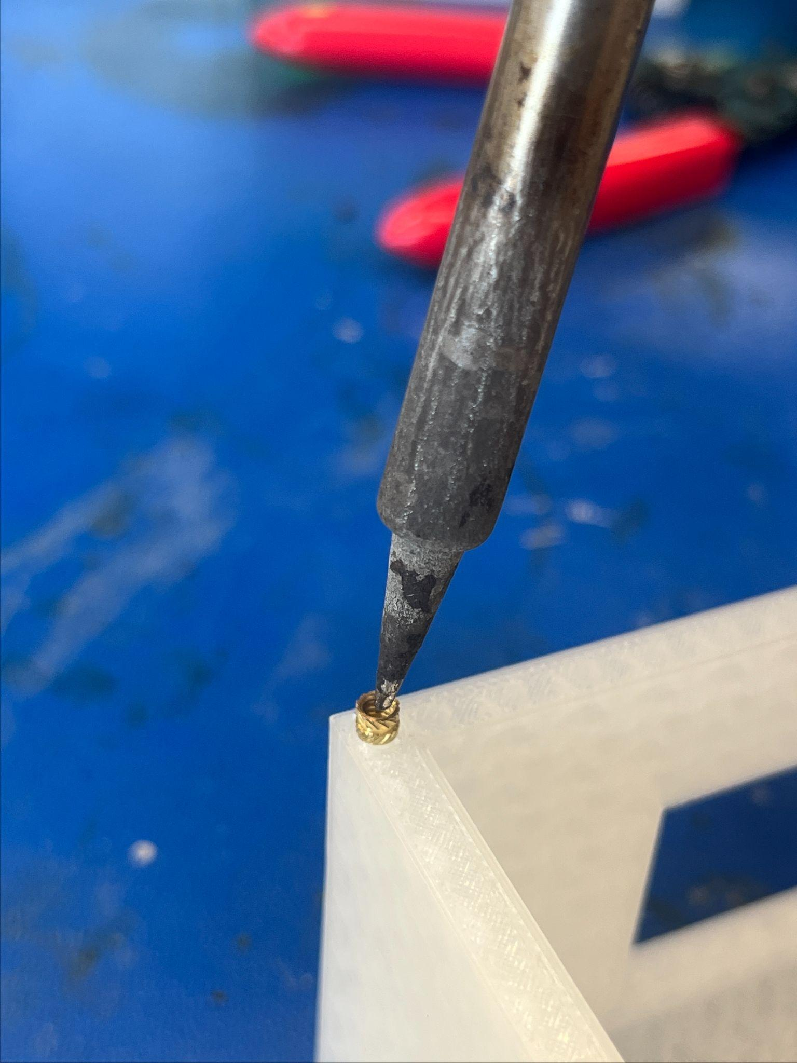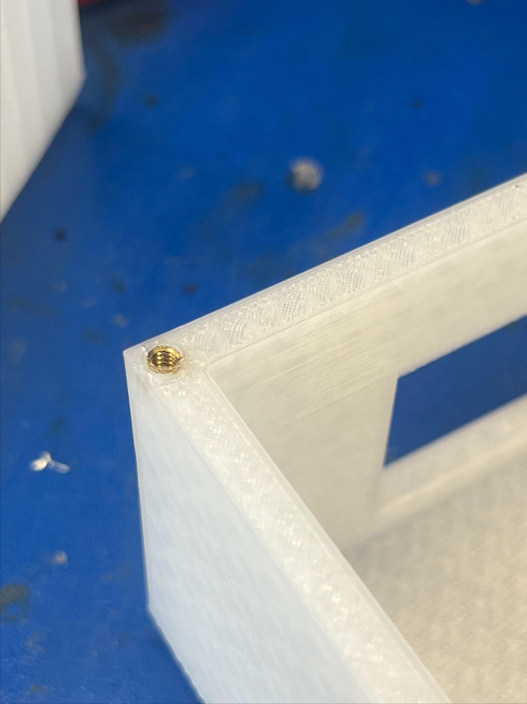
2. Wait ~3 minutes for the brass inserts and the standoffs to cool. Place PCB on standoffs to confirm correct placement of brass inserts. Use the soldering iron to adjust brass insert as necessary. Repeat steps 3-4 until all four standoffs and all four corners are set up.